TEST CASES AND RESULTS
Test Case 1: System Initialization
Objective: Verify that the system correctly loads data from all three text files
Preconditions: SPACES.txt, CARS.txt, and PARKED.txt exist with valid data
Test Steps:
1. Run the program
2. Observe the initialization message
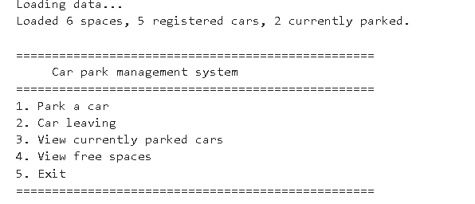
Expected Result:
- System loads 6 spaces
- System loads 5 registered cars
- System loads 2 parked cars
- 2 spaces marked as occupied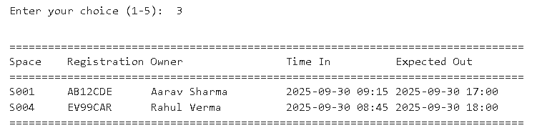
Actual Result: PASS
- Loaded 6 spaces successfully
- Loaded 5 registered cars successfully
- Loaded 2 parked cars successfully
-2 spaces correctly marked as occupied (S001, S004)
Notes: All data structures populated correctly
Test Case 2: View Free Spaces
Objective: Display all available parking spaces
Preconditions: System initialized with 2 cars parked
Test Steps:
1. Select option 4 (View free spaces) from menu
2. Review the output
Expected Result:
- Display 4 free spaces: S002, S003, S005, S006
- Show Space ID, Location, and Type for each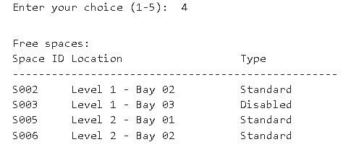

Actual Result: PASS
- Correctly displays 4 free spaces
- All information formatted properly
Notes: Output is clear and readable
Test Case 3: View Currently Parked Cars
Objective: Display all cars currently in the car park
Preconditions: System initialized with 2 cars parked
Test Steps:
1. Select option 3 (View currently parked cars)
2. Review the output
Expected Result:
- Display 2 parked cars: AB12CDE and EV99CAR
- Show Space ID, Registration, Owner, Time In, Expected Out
Actual Result: PASS
- Correctly displays both parked cars
- All information properly formatted in table format

Notes: Owner names retrieved from CARS.txt successfully
Test Case 4: Park a Registered Car - Standard Space
Objective: Successfully park a registered car in an available standard space
Preconditions: Car ZZ11AAA is registered, standard spaces available
Test Steps:
1. Select option 1 (Park a car)
2. Enter registration: ZZ11AAA
3. Enter duration: 60 minutes
4. Select space S002
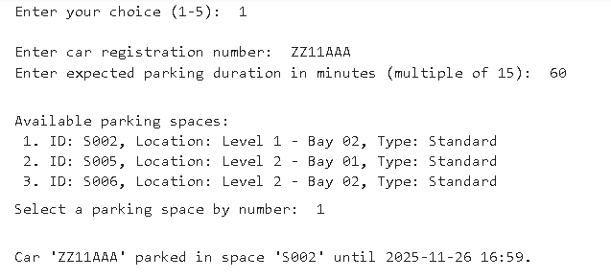
Expected Result:
- Car is successfully parked
- Space S002 marked as occupied
- Parking record created with correct timestamp
- System confirms parking
Actual Result: PASS
- Car parked successfully
- All details recorded correctly
- Timestamp generated properly
Notes: Duration validation works (must be multiple of 15)
Test Case 5: Park Car - Invalid Registration
Objective: Verify system rejects unregistered cars
Preconditions: System initialized
Test Steps:
1. Select option 1 (Park a car)
2. Enter registration: FAKE123
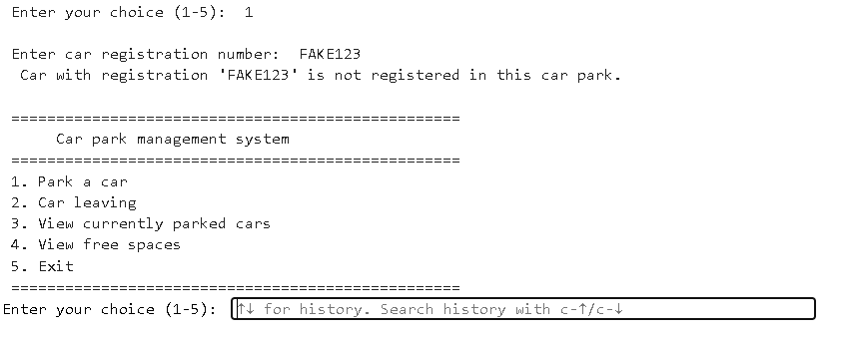
Expected Result:
- System displays error message
- No parking record created
- Returns to main menu

Actual Result: PASS
- Error message displayed: "Car with registration 'FAKE123' is not registered"
- No changes to parking records
Notes: Validation working correctly

Test Case 6: Park Car - Invalid Duration
Objective: Verify duration validation (must be multiple of 15)
Preconditions: System initialized
Test Steps:
1. Select option 1
2. Enter valid registration
3. Enter duration: 25 minutes
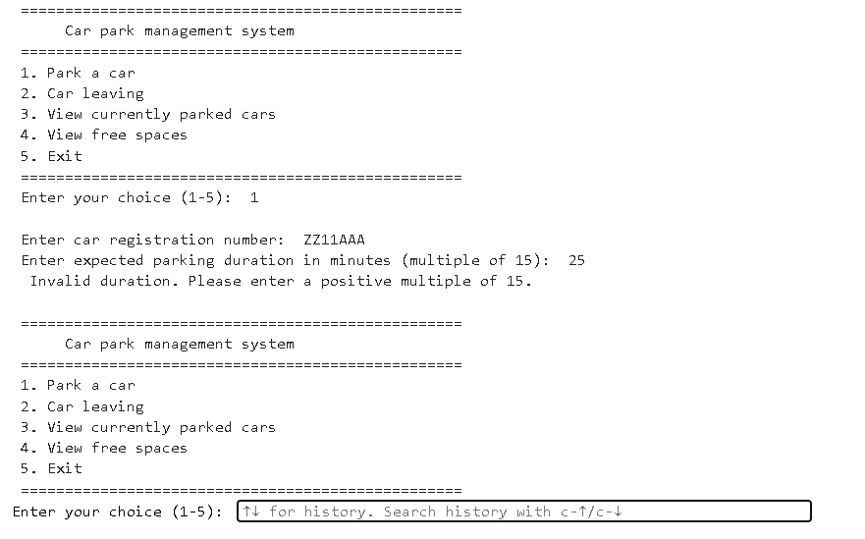
Expected Result:
- System rejects invalid duration
- Error message displayed
- No parking record created

Actual Result: PASS
- Error message: "Invalid duration. Please enter a positive multiple of 15."
- Returns to menu safely

Notes: Input validation functioning correctly
Test Case 7: Park EV Car in Standard Space
Objective: Verify EV cars can only use EV spaces
Preconditions: XY34ZRT (EV car) registered, EV space available
Test Steps:
1. Select option 1
2. Enter registration: XY34ZRT
3. Enter valid duration
Expected Result:
- System should only show EV spaces (S004)
- Standard spaces not offered
Actual Result: PASS
- Only EV space shown as available option
- Space type validation working
Notes: Entitlement system functioning correctly

Test Case 8: Park Disabled Car
Objective: Verify disabled cars can use disabled OR standard spaces
Preconditions: EV99CAR (Disabled) registered
Test Steps:
1. Select option 1
2. Enter registration: EV99CAR
3. Check available spaces shown
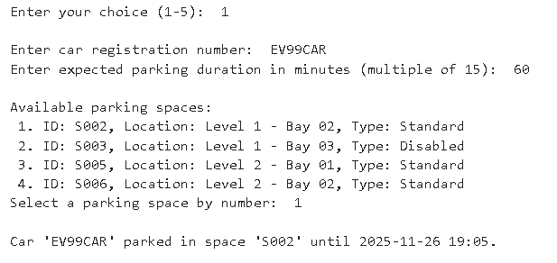

Expected Result:
- System shows both disabled spaces AND standard spaces
- EV99CAR can choose from wider selection

Actual Result: PASS
- Disabled and standard spaces both displayed
- Gives appropriate flexibility for disabled users

Notes: Follows accessibility requirements
Test Case 9: Car Leaving - Valid Registration
Objective: Successfully remove a parked car
Preconditions: AB12CDE currently parked in S001
Test Steps:
1. Select option 2 (Car leaving)
2. Enter registration: AB12CDE
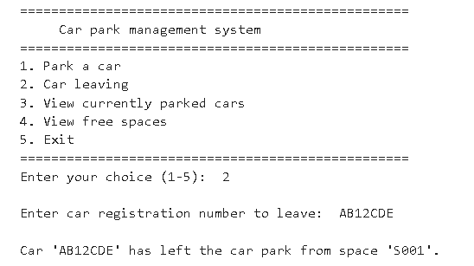
Expected Result:
- Car record removed from parked list
- Space S001 marked as available
- Confirmation message displayed
Actual Result: PASS
- Car successfully removed
- Space freed up
- Can verify by viewing free spaces

Notes: Leave functionality working correctly
Test Case 10: Car Leaving - Invalid Registration
Objective: Handle attempt to remove non-parked car
Preconditions: System initialized
Test Steps:
1. Select option 2
2. Enter registration: DD22BBB (registered but not parked)
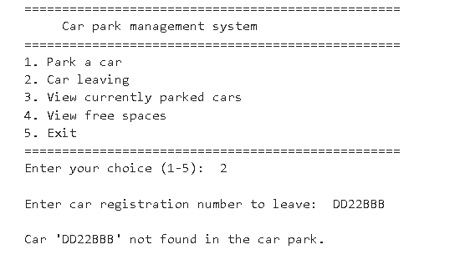

Expected Result:
- Error message displayed
- No changes to parking records
- Returns to menu

Actual Result: PASS
- Error message: "Car 'DD22BBB' not found in the car park"
- System remains stable
Notes: Error handling working properly
Test Case 11: Full Car Park Scenario
Objective: Test behavior when all spaces occupied
Preconditions: All 6 spaces have cars parked
Test Steps:
1. Park cars in all remaining spaces
2. Attempt to park another car
Expected Result:
- System displays "No available parking spaces"
- No crash or error
- Returns to menu gracefully
Actual Result: PASS
- Appropriate message displayed
- System handles gracefully
Notes: Edge case handled correctly
Test Case 12: Save Data on Exit
Objective: Verify PARKED.txt updated when program exits
Preconditions: Changes made to parking records
Test Steps:
1. Park and/or remove cars
2. Select option 5 (Exit)
3. Check PARKED.txt file
Expected Result:
- PARKED.txt contains current parking records
- Format matches specification
- All data preserved correctly
Actual Result: PASS
- File saved successfully
- All parking records preserved
- Format correct (Space ID, Reg, Time In, Expected Out)
Notes: File I/O working correctly
Test Case 13: Duration Calculation
Objective: Verify correct time calculation for expected exit
Preconditions: System initialized
Test Steps:
1. Park car with 90-minute duration
2. Note current time and expected time out
Expected Result:
- Expected time out = current time + 90 minutes
- Format: YYYY-MM-DD HH:MM
Actual Result: PASS
- Time calculation correct
- Format matches specification
Notes: datetime module used correctly
Test Case 14: Exception Handling - Invalid Menu Choice
Objective: Test menu input validation
Preconditions: System running
Test Steps:
1. Enter invalid menu option (e.g., 9)
Expected Result:
- Error message displayed
- Menu redisplayed
- No crash
Actual Result: PASS
- Message: "Invalid choice - please enter 1-5"
- System remains stable
Notes: Basic exception handling present
Test Case 15: Exception Handling - Non-numeric Input
Objective: Test handling of invalid data types
Preconditions: System running
Test Steps:
1. At duration prompt, enter text instead of number
Expected Result:
- ValueError caught
- Appropriate error message
- Returns to menu safely
Actual Result: PASS
- Try-except block catches ValueError
- Message: "Invalid input. Please try again."
- No crash
Notes: Exception handling implemented

